Assignment 1
Student Name: Mary Babu
Course: Big Data 1
Instructor: Prabhpreet Sidhu
Date: October 16, 2025

Contents
Introduction 2
Data Cleaning 3
Exploratory Data Analysis (EDA) 5
Tactic Analysis: 5
Platform Analysis 7
Trend Analysis: 9

Introduction
The purpose of this case study is to analyze Kroger’s marketing campaign dataset to gain insights into how spending is distributed across different tactics, platforms, and campaigns. The goal is to identify which areas received the highest and lowest investment and to understand trends in spending overtime.
The analysis was performed using Python (Pandas, Matplotlib, and Seaborn). The data was cleaned, processed, and visualized to discover spending patterns and trends. Based on the findings, recommendations are provided to help improve marketing effectiveness and budget allocation.

Data Cleaning
- Before loading the data, I imported pandas for data manipulation and matplotlib.pyplot for plotting charts. Then I read the CSV file Kroger_CSD.csv into a pandas DataFrame called df.

Codes used:
import pandas as pd
import matplotlib.pyplot as plt
df = pd.read_csv('/Workspace/Users/n01735817@humber.ca/Kroger_CSD.csv')

- Before analyzing the dataset, I cleaned the data to make it suitable for analysis.
The steps that include are:
- Removing unwanted characters like dollar signs ($) and commas from the “Spend” column.
- Converting the “Spend” column into numeric format.
- Converting date values into proper date format.
- Extracting the month from the date column to study spending trends over time.

Codes used:
# Clean the 'Spend' column
df['Spend'] = df['Spend'].replace(r'[\$,]', '', regex=True).astype(float)
# Convert 'Dates' column to date format
df['Dates'] = pd.to_datetime(df['Dates'], format='%m/%d/%Y', errors='coerce')
# Extract month from date
df['Month'] = df['Dates'].dt.to_period('M').astype(str)
# Show first few rows to confirm
print(df.head())
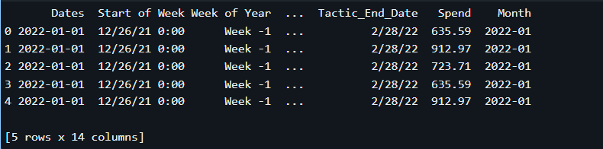

- Then I printed the count of missing values in each column to assess data quality.
Codes used:
print("Missing values per column:")
print(df.isnull().sum(), "\n")

Exploratory Data Analysis (EDA)
I performed an initial review of the data to understand the budget allocation. This analysis focused on four key areas:

Tactic Analysis:
Determined the highest and lowest spending marketing activities:
- Top Total Spend by Tactic:
tactic_spend = df.groupby('Tactic')['Spend'].sum().reset_index().sort_values(by='Spend', ascending=False)
print("Top 5 Tactics by Spend:")
print(tactic_spend.head(), "\n")

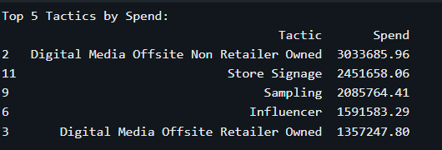

- Lowest Total Spend by Tactic:
print("Lowest 5 Tactics by Spend:")
print(tactic_spend.tail(), "\n")

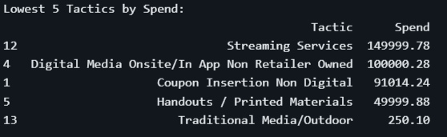

- Visualization
import seaborn as sns# Plot spend by tactic
plt.figure(figsize=(12, 8))
sns.barplot(data=tactic_spend, y='Tactic', x='Spend')
plt.title('Total Spend by Tactic')
plt.tight_layout()
plt.show()

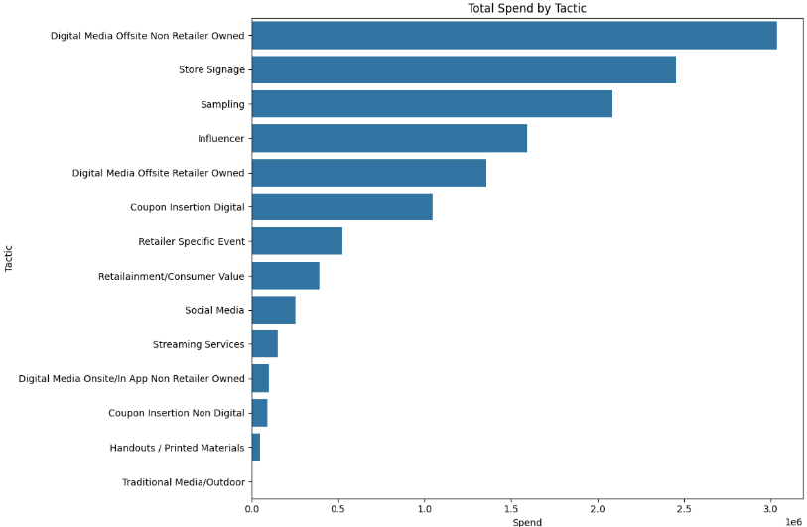

Platform Analysis
Identified the advertising platforms that received the most and least investment.
Calculate total spend by Platform
- Top 5 platforms by spend
platform_spend = df.groupby('Platform')['Spend'].sum().reset_index().sort_values(by='Spend', ascending=False)
# Display top and bottom platforms
print("Top 5 Platforms by Spend:")
print(platform_spend.head(), "\n")

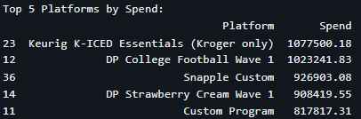

- Lowest 5 platforms by spend
print("Lowest 5 Platforms by Spend:")
print(platform_spend.tail(), "\n")

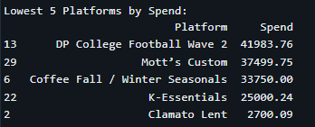

- Visualization
plt.figure(figsize=(12, 8)) # Increased figure size for better visibility
sns.barplot(data=platform_spend, y='Platform', x='Spend') # Swapping X and Y
plt.title('Total Spend by Platform')
plt.tight_layout() # Ensures everything fits
plt.show()

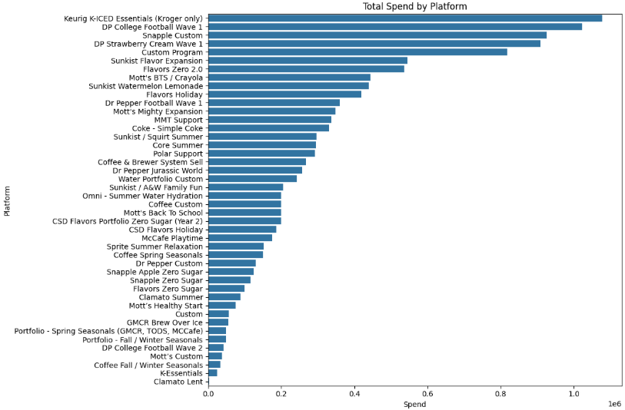

Campaign spend Analysis:
Compared spending across all campaigns to see the concentration of the budget.
- To Display top campaigns
print("Top 5 Campaigns by Spend:")
print(campaign_spend.head(), "\n")

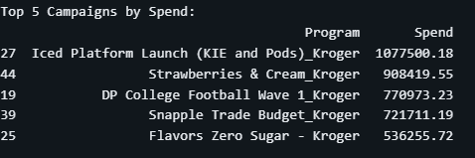
- To display lowest campaigns
print("Lowest 5 Campaigns by Spend:")
print(campaign_spend.tail(), "\n")

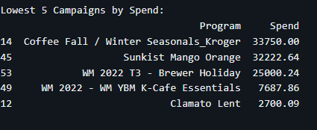

- Visualization
plt.figure(figsize=(12, 8)) # Increased figure size
# Swap x and y: 'Program' (labels) goes on the y-axis, 'Spend' (value) goes on the x-axis
sns.barplot(data=campaign_spend.head(10), y='Program', x='Spend')
plt.title('Top 10 Campaigns by Spend')
plt.tight_layout() # Ensures all program names are fully visible
plt.show()

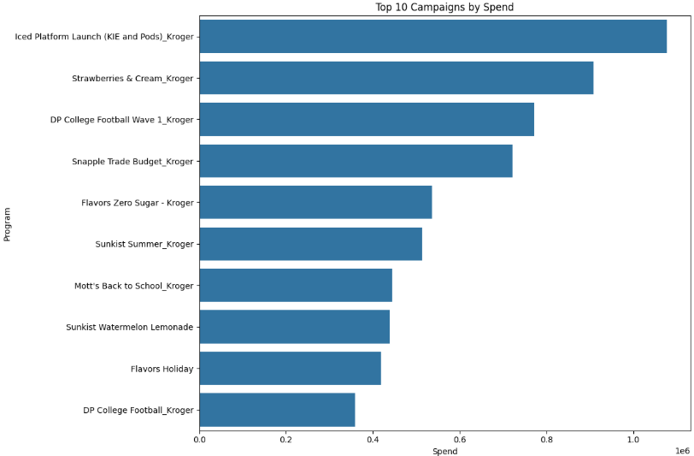

Trend Analysis
Examined spending over time to reveal if the investment was consistent or had sharp increases (spikes).

# Calculate total spend per month
monthly_trend = df.groupby('Month')['Spend'].sum().reset_index()
# Plot trend
plt.figure(figsize=(12,6))
sns.lineplot(data=monthly_trend, x='Month', y='Spend', marker='o')
plt.title('Monthly Spend Trend Over Time')
plt.xticks(rotation=45)
plt.tight_layout()
plt.show()

